Lecture 5
Which UML diagram types do you remember?:
Use case diagram, sequence diagram, class diagram, deployment diagram

What is a domain model:
A domain model is a diagram that describes the business concepts and their relationships, focusing on the problem domain rather than the software solution.

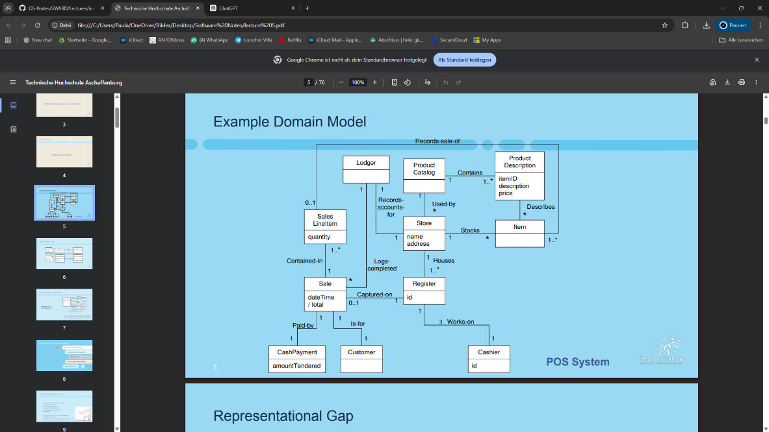

Representational Gap:
Between the domain model and the Design model, domain model focuses on the business, and the relationships but there is not technical code.
The Design: model Focuses on the software solution. Contains classes, attributes, methods, and implementation details.
The Domain Model describes business concepts, while the Design Model describes software classes. The software classes are inspired by the business concepts.
The object model works or looks the same as the class diagrams, where each class has methods and what they return and variable names and what they store.

Recap: Maintainability ISO 25010:
Increasing or rushing the development delivery of a software most of the times comes at the cost of the software’s quality, we have 2 persepctives of quality the outer and the inner quality,
The outer quality is the user’s perspective, meaning the user experience, the performance, and reliability
The inner quality perspective is from the developer’s perspective. Meaning the code readability, easiness of modifications and understanding, debugging and so on (maintainability)
75% of software costs comes in maintenance, meaning, fixing bugs, enhancing the performance adaptation to the environment.
Maintainability: “The degree of effectiveness and efficiency with which the product can be modified.“

How do we measure maintainability?:
As per the lectures we can measure code quality/maintaibility by how many wtf/minute
Maintainability is usually measured by looking at how easy it is to modify, understand, test, and extend the software.

Responsibility-Driven Design (RDD)
In Responsibility-Driven Design (RDD), software objects are modeled based on real-world domain concepts (such as roles, entities, and events). Each object represents a concept from the domain, and responsibilities are assigned to these objects based on their behavior and interactions in that domain.
A responsibility is something an object is expected or required to do or know in the system.
Doing:
Doing a calculation, creating an object, create an action in another object, synchronize or control the work flow of a certain part of the system.
Knowing:
What information an object is responsible for storing, remembering, or being able to figure out.
Knowing about its own encapsulated data, knows what other classes its related to meaning it has references of classes its related to inside of it.
“Knowing about things it can derive or calculate” means an object is responsible for computing certain values based on its own data and related objects instead of storing them directly.
so a responsibility is an idea that we can represent into a method or more than one method collaborating together to deliver this responsibility. A responsibility is a high level thing and it does not always have to corrosponde to one method
a responsibility can be anything complex from a single method or line into a multiple lines and methods. For example the responsibility to give access to the data in the database might include tons of code while one that creates a new object might be a single liner bean creator.

Responsibilities are typically assigned using UML interaction diagrams (sequence or communication diagrams)
We cannot use the arrow direction to determine the responsibility owner
Sale object in this example is responsible for creating the object of payment (sends an arrow) and handling the payment (received arrow)

Example: enterItem
so inside the register there is a method called makeLineItem() that calls for the sale object and the sale object now is responsible for implementing this and creating and managing and istance of the LineItem
from a responsibility persepctive the register receives an item and item id, and calls the sale and that its resposnibility the responsibility of the sale is to create a sale item when its called in this context

Systematic Approach to Assigning Responsibilities:
From use cases, we can identify system responsibilities and then assign them to appropriate objects in the design model.
A simple guideline for doing this is the (Information) Expert Pattern:
We assign responsibilities to the object that has the necessary information to perform them (Information Expert). First, we look for suitable classes in the design model; if none exist, we check the domain model to see if a conceptual class can be added. If no appropriate domain object exists, we introduce a new supporting class such as a Controller or a Pure Fabrication to handle the responsibility.

Example: Sale GrandTotal Responsibility:
A SaleLineItem = a row of data of what product was bought what price and how many
we have to now figure out who has access to enough data to calculate the grand total which in this case is the Sale class, so we assign getTotal() to it, and the flow of responsibility is that the total is calculated inside the sale by summing the getPrice inside the LineItem for each element, which gets the price for each item from the item object too.
Sale: know sales total
SalesLineItem: know line item subtotal, it stores a reference to the item and the quantity of it
ProductDescription: know product price

Dynamic Design Mode:
A dynamic design model shows how the system behaves over time and is mainly represented using UML sequence or communication diagrams, which are more important than class diagrams because they show real interactions between objects; they are built using system operations, the domain model, and design patterns, where messages in the diagrams represent the operations that will later appear in the class design.

Static Design Model:
A static design model describes the structure of the system after interaction diagrams are created, allowing us to identify the software classes involved in the solution; these classes are then detailed in a Design Class Diagram (DCD), which shows attributes, methods, interfaces, relationships, and dependencies, and in practice it is developed together with interaction diagrams to define how the system is both structured and implemented.

interactions can be used to declare methods; messages in interaction diagrams indicate operations in the class diagrams
classes identified in the interaction diagrams are declared in the class diagrams

Agile Modelling:
In Agile, early diagrams (like UML sequence or class diagrams) are NOT meant to be final or perfect.
Instead, they are used to: talk with teammates, understand requirements, explore ideas
Another reason initial models are not perfect are because more questions might arise in future deeper questions regarding functional and non-functional requirements that might enforce changes on the model
In Agile Modeling, UML is used as a lightweight communication and thinking tool in early design. Models are expected to be incomplete and evolving, as they help uncover new requirements and questions. Heavy tools should be avoided early on, and formal UML diagrams are only created later for documentation purposes.

Patterns are used in which of the following?:
software architecture, object design , implementation/coding

GRASP (Principles) General Responsibility Assignment Software Patterns:
Pattern: “a named description of a well-known problem and solution that can be applied to new contexts; ideally, a pattern advises us on how to apply its solution in varying circumstances and considers the forces and trade-offs”
GRASP and other design patterns help us map the domain model and the real world objects and responsibilities into a class diagram for example, by following certain rules.
GRASP consists of 9 core rules (principles) that guide how to design object-oriented software properly.
1. Information Expert or just “Expert” (the pattern we just applied) 2. Creator 3. Controller
4. Low Coupling 5. High Cohesion 6. Polymorphism 7. Pure Fabrication 8. Indirection
9. Protected Variations

Relationship between GoF and GRASP:
GoF is gang of four and its another OO design pattern
GRASP represents fundamental object-oriented design principles and can be seen as the “alphabet” of design patterns, while GoF and other design patterns are more specialized solutions that build on or apply these principles.
GRASP will be referred to as design principles

